**An insight into Google and its products**Google is one of the biggest & developing internet giants known to almost all of us.   
What comes into our mind after hearing the word Google is its search feature. But Google is not only a specialist in searching the web but also in providing many other services about which we will discuss in this issue. We will highlight the most popular products Google has made and we will take an insight into the Google world to get a complete idea about each of them. Google’s name is derived from the term Googol (10100) and was founded by   
Sergey Brin & Larry Page as a research project at Stanford University. It was initially codenamed Backrub. Google’s first product was Google Search after which it had acquired and developed many other products. Let us have a look at each of them. **Google Search**

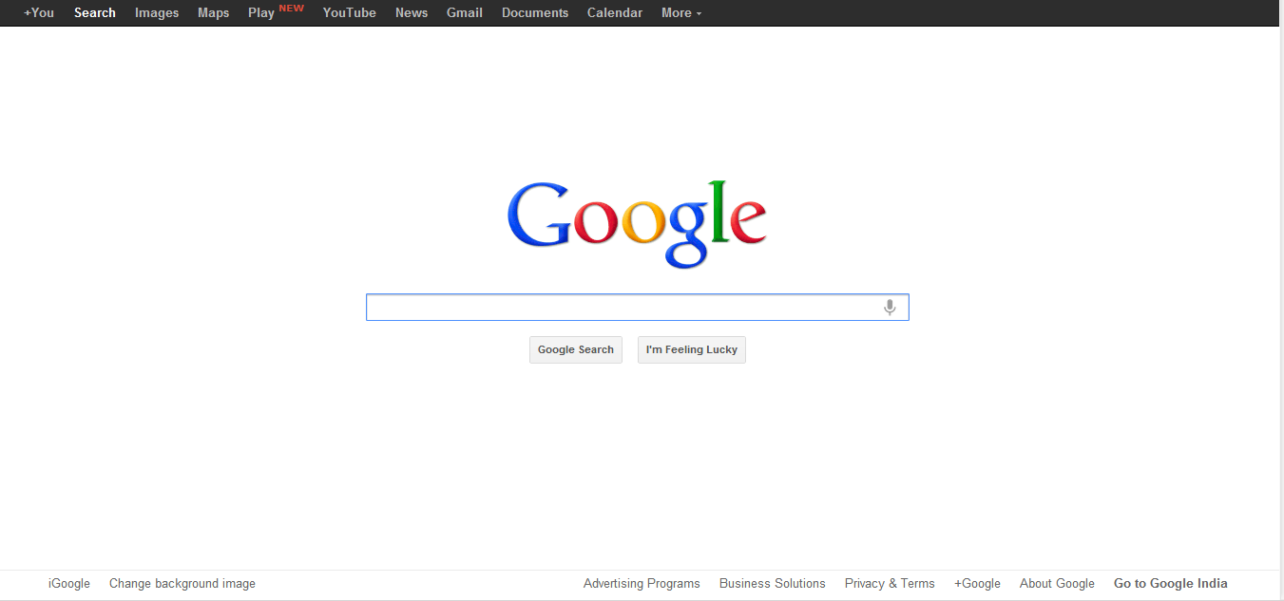

This marks Google’s main success all over the years being used by many people worldwide.   
This remains the homepage of most of the people and the service it provides in amazing.  
Simplicity and accuracy remains Google’s main key thus driving a lot of traffic to its website. Google remains the most visited website in the world due to this Google Search feature.  
  
Categories under Google Search:

**Web Search:** Type in the search terms/keywords and you get the search results having the website you are looking for. The search terms can include any phrase or words provided its sensible and Google will find the best match for you. The main problem which people face is regarding filtering out the search results. If an user wants to narrow down the search results with some specifications, he/she can do the same by adding some search filters. This can be either done using Advanced Search option available in the top right position of the page or using few predefined keywords.

**allinanchor**: Narrows down your search only to page url having the keyword.   
Eg. If the query is “allinanchor:ahoy” Google narrows down the results to display all websites having links where the text displayed in the link is “ahoy”.  
 **allintext:** Narrows down the search result to show only the pages having the keyword as a word in the webpage.   
Eg. If the query is “allintext:tech ahoy” Google narrows down the result to show only the pages having the words “tech” and “ahoy”

**allintitle:** Narrows down the search result to display only the pages having the keyword as the title of the webpage.  
Eg. If the query is “allintitle:tech ahoy” Google narrows down the result to display only the pages having the words “tech” and “ahoy” in the title bar of the browser.

**allinurl:** Narrows down the search result to display all the websites having the keyword in the website address.  
Eg. If the query is “allinurl:tech ahoy” Google narrows down the result to display only the pages having words “tech” and “ahoy” in the url.

**author:** “data author:vignesh author:tv” or “data author:name@example.com” returns articles that contain the word “data” written by vignesh tv or name@example.com.

**cache:** “cache:www.example.com” will show the cached version of the website www.example.com

**filetype: “**tech ahoy filetype:pdf” will display all the pdf files which match the terms “tech” and “ahoy”

There are many other filters available in Google which can be used. For more information, you can refer http://www.googleguide.com/advanced\_operators.html   
  
**Image Search:**

Recently Google has achieved a new dimension in image search where people can put in text to search for images related to the text or they can put in their own images in order to identify their source, know their description or look for copies. This tool has been very helpful to all the people as image to image search is a new concept introduced by Google.  
The filters applicable in normal web search are also applicable in image search.  
  
Moreover, when an image search is made, the user can specify the resolution of the image which he/she requires, size, format, layout, etc. so that appropriate images can be obtained.

**Google Chrome:**

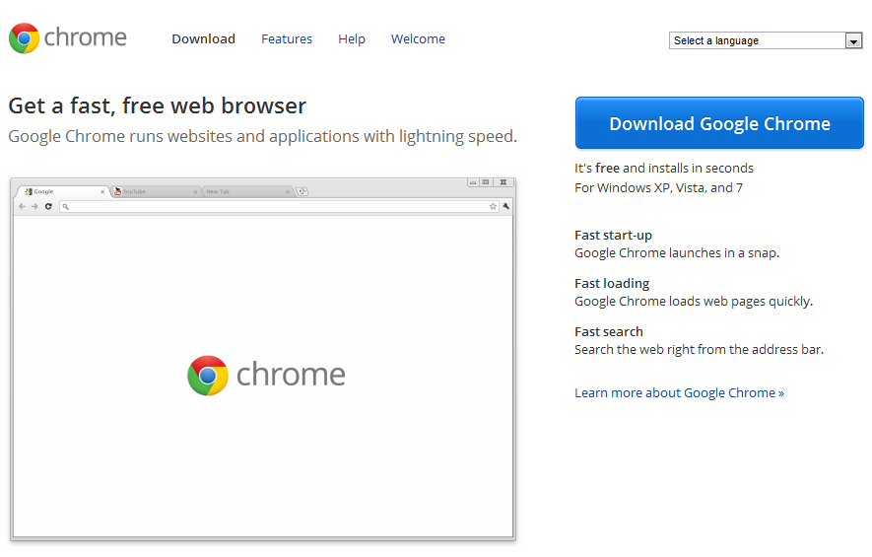

A legendary, developer friendly browser rattling the whole browser market, with almost full support of HTML-5 features and lots more to talk about in this context.

It made its first debut beta version on 2nd of September 2008 impressing almost all the people with its simple and elegant looks. The market for other browsers like Internet Explorer and Firefox started falling down soon after its release. It was the only browser left without hacking at the annual HACKFEST.

All these were the main things which made a common layman switch to a browser like chrome.

Does it have anything beyond this? If yes, what is it? That is what we would like to share here.

It is very much user friendly as people don’t have to do anything except for enjoying browsing. It has very commonly used plugins like Adobe Flash pre-installed leaving the user with no work. It updates all the pre-installed plugins automatically which leaves the user with no work. Even the whole browser updates automatically and you don’t have the pain of downloading every new version and installing it onto your computer.

Its speed is undoubtedly high due to its heavy caching facilities which makes the most commonly visited pages to be loaded very fast. A sample video made by GOOGLE itself can be seen at <http://www.youtube.com/watch?v=nCgQDjiotG0> where they compare the loading speed of the browser with potatoes, lightning etc.

It has its own personalised task manager where you can view the processes running in the browser and the memory its consuming and even allows you to stop services if you don’t want them.

It has its own web store where you can get extensions, apps and themes which customizes the look, feel and usability of your browser. It even allows you to develop extensions, apps and themes very easily that, the developer need not run behind the SDK, and other software. All you need is the browser.

The web store can be found at <http://www.chrome.google.com/webstore> and you have a lot of free as well as paid apps, extensions and themes you can use. We will be seeing more about this in the apps & extensions section of this magazine.

**For developers**

Supports webkit, which is an excellent implementation of CSS for the new generation.

Supports almost all the features of HTML-5

It has an excellent feature “Inspect Element” which will be very helpful for developers to trace how a part of the website is made, trace the way the website loads, images used in the website and even shows you the CSS, JAVASCRIPT AND HTML pages which were loaded in the website. It helps you a lot when you want to try re-implementing a feature of an already made website.

Supports both latest as well as deprecated HTML tags

There is an extension named Web Developer for chrome which can be very much helpful to you in developing a website, hacking it, understanding how it is made.

**Problems with Chrome**

The problem with chrome is that, all the versions are not so stable and most of the versions get released as alpha or beta. But the thing is, even its beta version is more than commendable.

**View of Web Developers**

Please use Chrome! This is how they will start!

**Reasons:**

Chrome supports all the exciting features needed for a perfect website like HTML-5, CSS-3, Webkit, Inbuilt Flash player, smooth JavaScript support. All these make Chrome exciting. The other browsers only support handful amount of these features while chrome keeps updating these. Even some of the deprecated tags (tags which has been removed from its standards by W3C) are also supported so as to give full functionality to the user.

So, what is the problem here?

When a web developer develops a website, he might use Chrome for developing and testing it. After he is done, it looks nice in Chrome. But later, if he opens the same website in Internet Explorer or similar browsers, the whole website appears distorted spoiling the look as most of the above mentioned features are not supported. So, the developer has to take pains in ensuring cross-browser compatibility and that will be a very difficult task. But there is a fact here. If the developer makes his website with the help of browsers like Internet Explorer, then it will be compatible with almost all the browsers as Internet Explorer follows all the W3C standards only without much of CSS-3 and HTML-5 support and the same thing is supported by other browsers too.

**OUR CONCLUSION**

The war of browsers still goes on! If we look back, we have a lot of browsers, some known and others unknown. But the best browser is one which you feel you are comfortable with no matter what features it provides. Browsers are meant for enhancing the browsing experience for the better. This article was written in my view towards Chrome. Any comments or suggestions are welcome.

**BLOGGER:**

www.blogspot.com  
It is a well-known useful feature meant for all the writers, bloggers and poets and this acts as a great platform to showcase literary work without much effort. All you need is a Google Account to start with and some theme for your blog. Everything else is provided by Google itself using good user interface. All you need to do is type in the content with proper formatting. This also acts as one of the good ways to get in touch with people of similar interests.   
  
There are lot of widgets provided to the user which can be added to your blog and this will improve the functionality of the blog. People are allowed to follow your blog, tweet posts, and share them in various websites, rate & comment on the posts and doing all these will add to the publicity of the blog.  
  
And if you are a web developer, you also have the option of inserting and editing HTML codes which makes blogger flexible to the user.

**Google Plus**:  
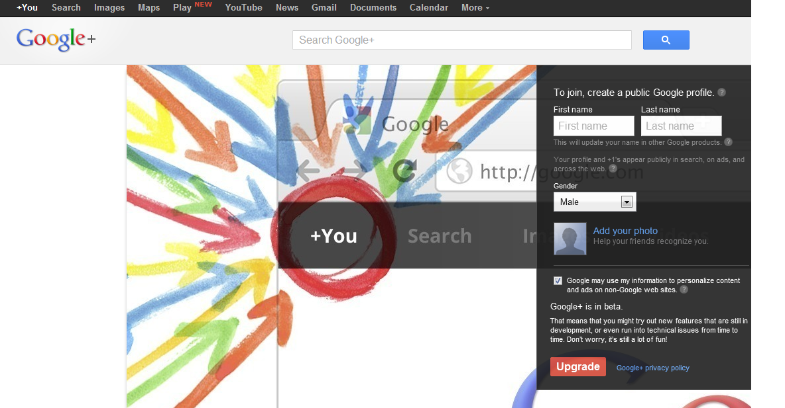

Google Plus was a revolutionary new introduction by Google this year, with excellent design and overwhelming features meant to improve social networking experience amongst people. All you need is a Google account to sign up and you are done.  
Google Plus is currently in Beta stage and constant improvisations are being made to its layout.  
Users are allowed to post, comment, share, +1, upload stuffs like what is available in Facebook but why should G+ be a revolutionary change?  
  
It is because of its new concept of Circles & hangouts.

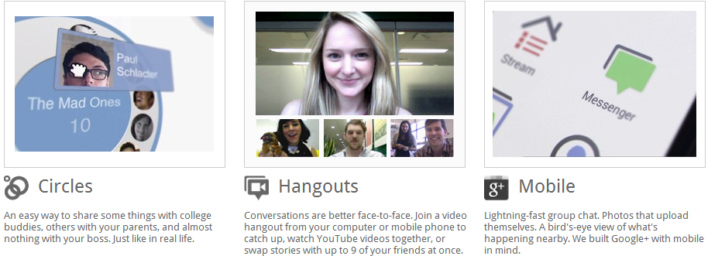

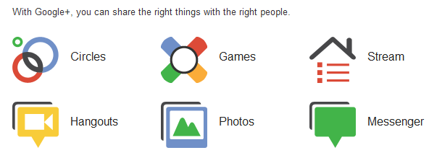

**Circles:**Your friends can be categorized into various domains called circles and this makes your communication private, easy and fun. It helps you in filtering messages and assigning visibility of stories. All you have to do is drag and drop.

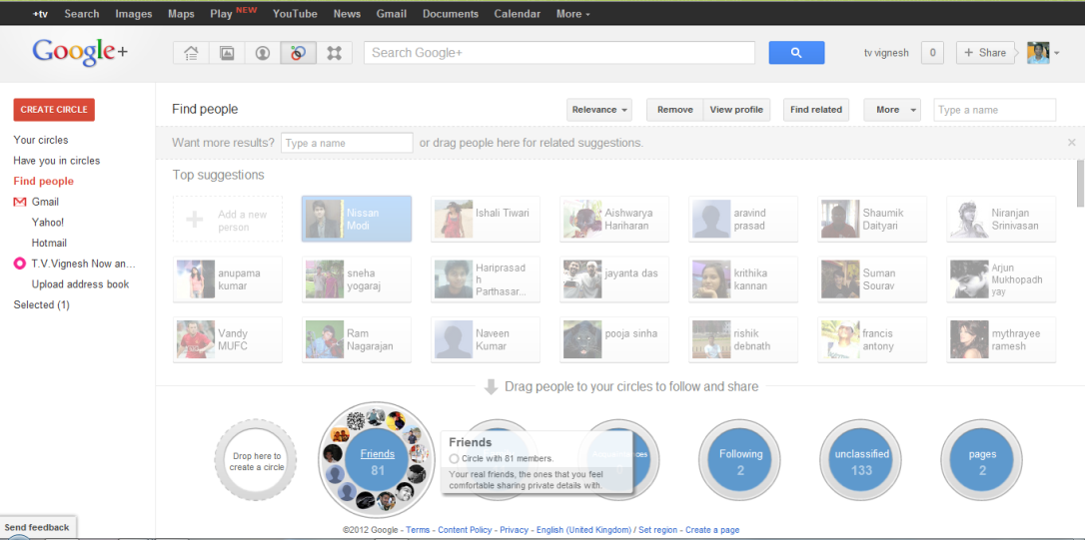

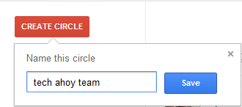

**Games:**Google Plus also allows users to play selected games online, thus enabling a social experience amongst all the people and also provides entertainment along with social networking.Even though the games at G+ are not as addictive as Farmville, they are still good for a person who just wants to while away some time.

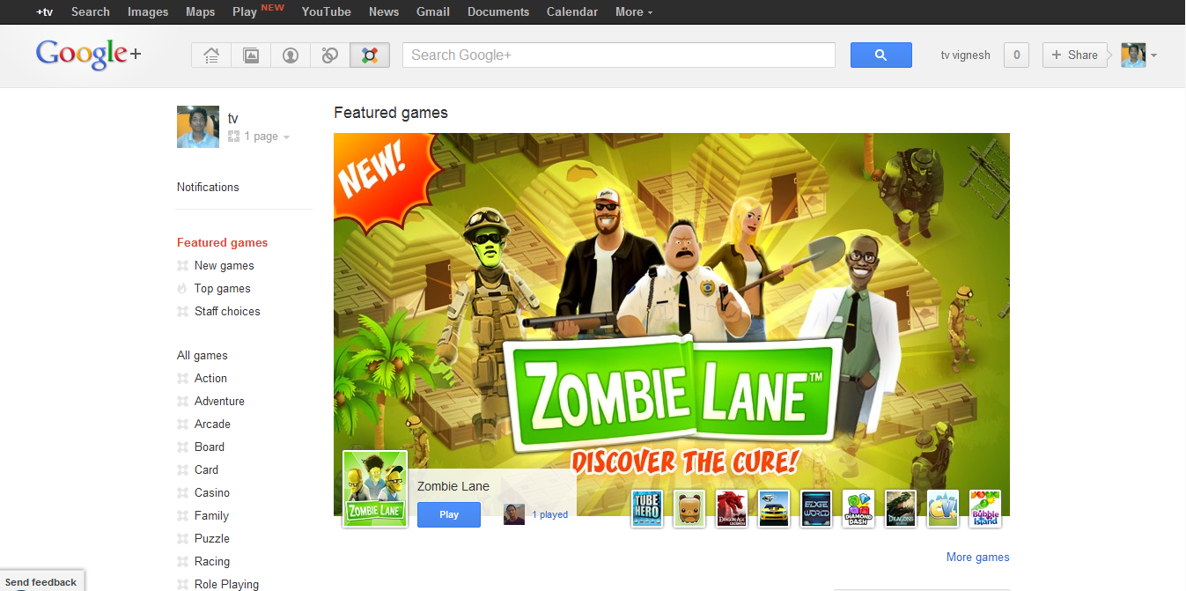

**Stream:**Facebook has its own newsfeed and in this case, G+ has its own stream where all the updates are available for the user to have a look. Filtering of updates is possible in G+ and you can also limit the number of updates to be displayed in a page so that the page does not look cramped with a lot of text. You can share your thoughts, upload pictures, video, documents and share links in the stream and all these shares will be visible to the people having you in their circles.

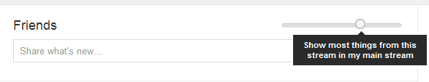

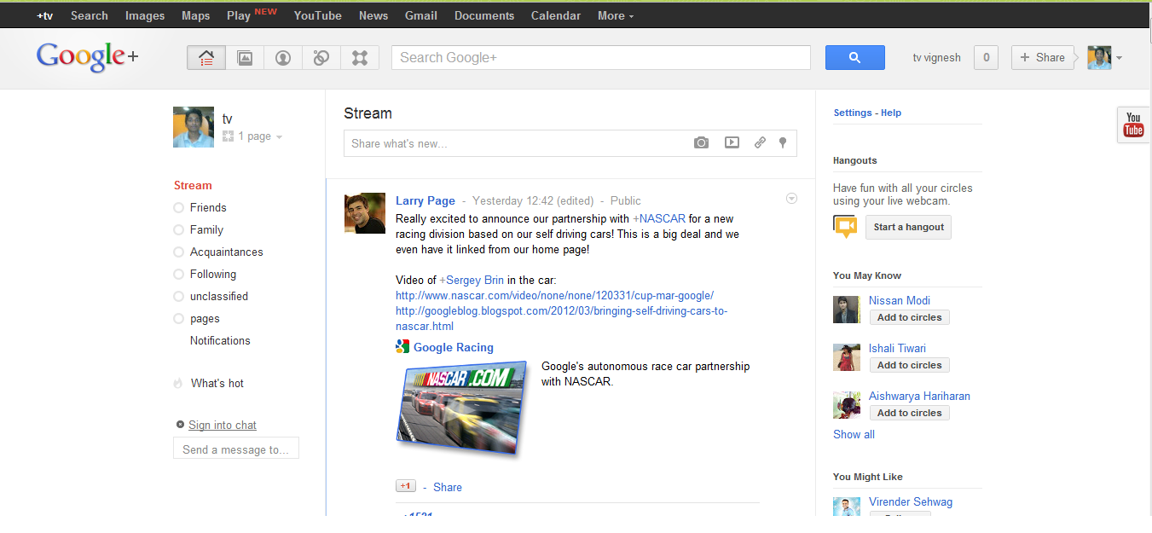

**Sharing a Post:**Sharing of posts is very simple and user friendly. You can even select the circles with whom you would like to share the post. So, this becomes very easy for the user.

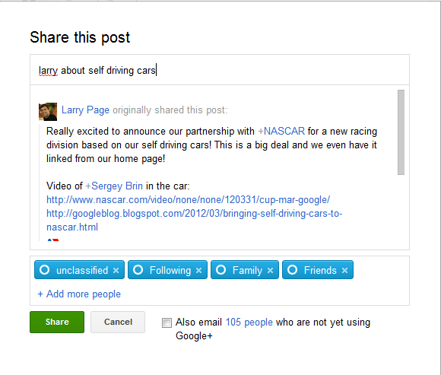

**Hangouts:**This is one of the main features of G+ enabling people to do good quality real-time video conferencing with many people at once. This service has caught the interest of many people and has been even used for conducting few meetings online. The video transmission speed and quality is very good and Google even identifies people’s gestures from this service.  
You can also have chats with all the people in your circles through this service.

**Photos:**

With Google+ you can also share your photos with others and it is even possible to share the photos from your mobile by downloading the Google+ App available for free download from the Android Market or iPhone App Store. The lightbox like effect also looks good when viewing a photo. It is even possible to share your picasa albums onto your G+ stream thus making the work a lot easier.

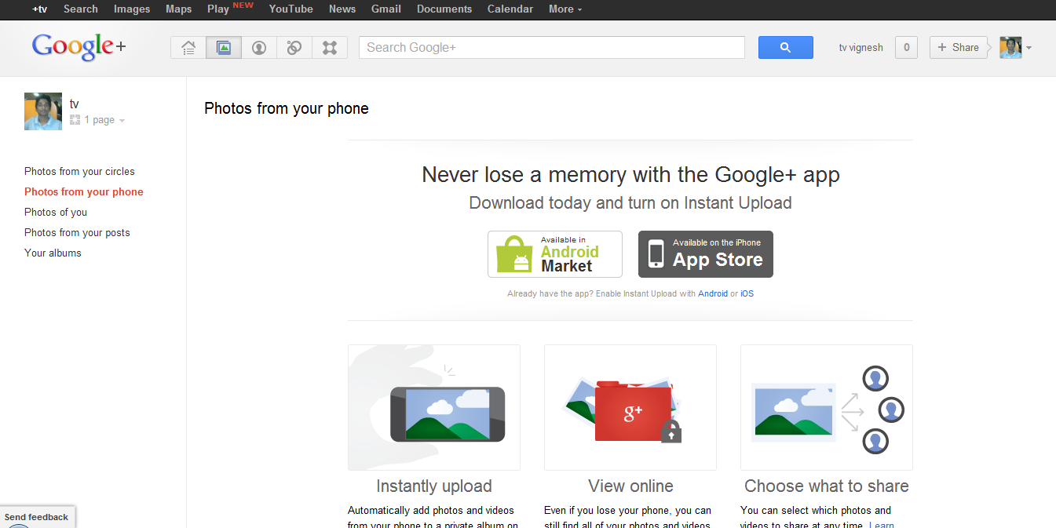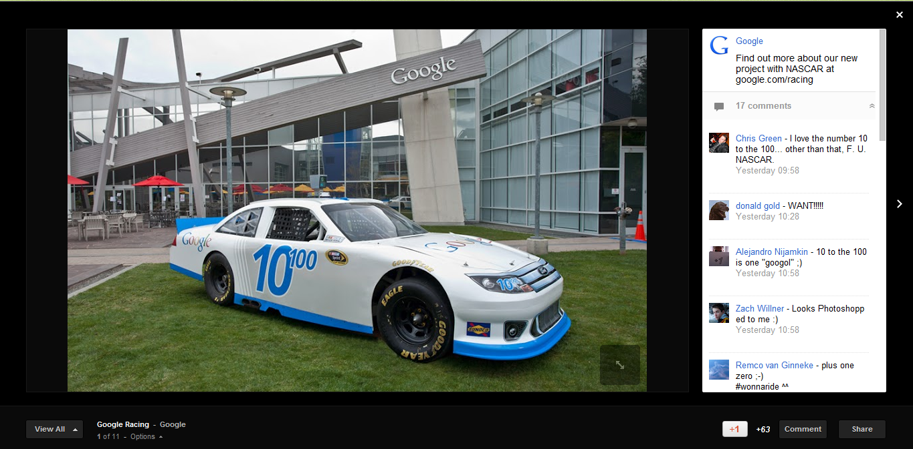

**The look of a simple G+ profile**

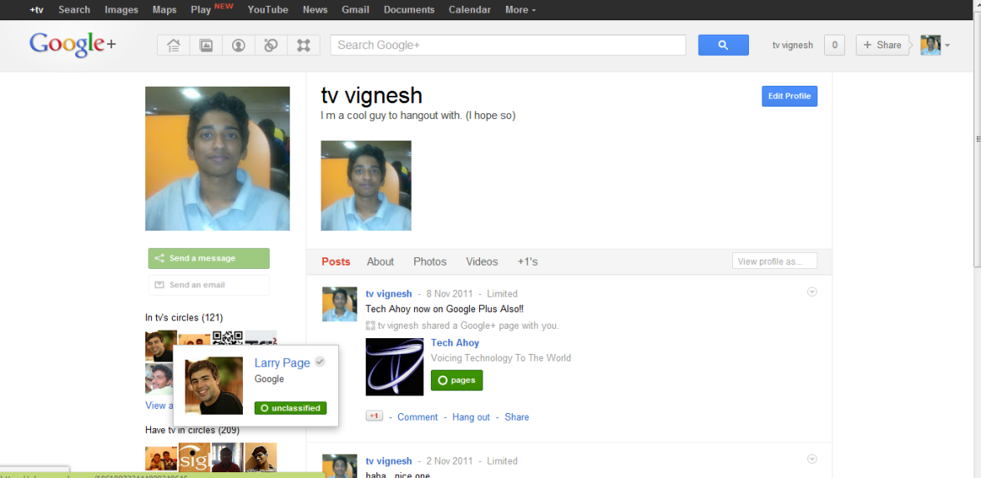

**Entertainment:**Apart from playing Games at G+ , you can also watch videos from youtube at the same time you are browsing and this makes the user stay in G+ without navigating to other websites. The video is not dynamically displayed but it is a popup which opens up when you would like to watch the videos.

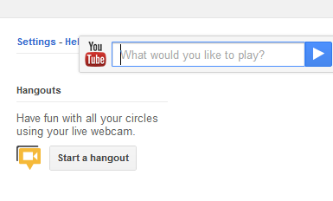

**Drawbacks of Google+:**

G+ is currently in beta version and faces few common problems which may be repulsive to the users.   
Few features like Pages have not been properly implemented since the communication is a bit more difficult than what it is in Facebook.  
Since G+ has just started, the games in it are not of much standard. Moreover it lacks the features like Apps in Facebook thus making G+ not so friendly for developers.  
It is very difficult to divert traffic from Facebook to G+ due to the already established communities at Facebook which won’t prefer navigating to Google Plus.

**Google Talk:**

Google Talk is a chat client like an IM which helps the user in establishing communication with all their contacts. Various modes of chatting is available in Google talk like video chat, text chat, etc. and Google maintains a log of each conversation sent/received so that it is easy to refer back by the user. It has many predefined profile pictures which can be set, variety of smileys which makes the chat very much interesting. All you need to do is visit www.talk.google.com ,download the client and install it onto your system.  
  
Apart from this, Google also offers a video chat plugin which when installed allows you to do video chatting from Gmail, Orkut, iGoogle, etc.

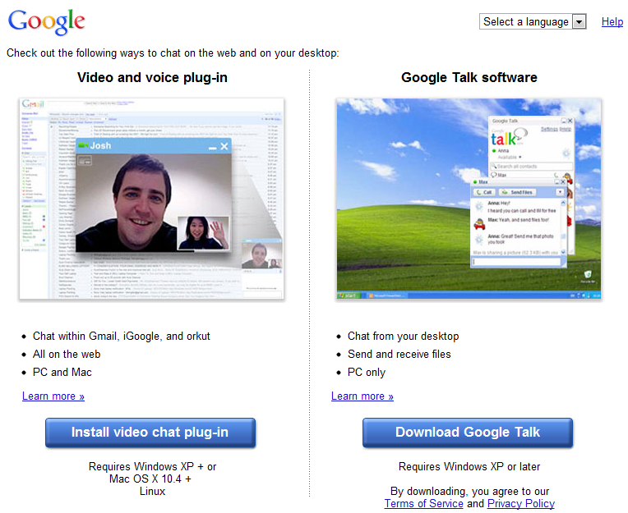

**Picasa & Picasa Web:**

Picasa has become one of the best image viewers due to its ease of editing, stylish look and also due to the ease of uploading the albums directly to Picasa web.  
For a layman who has not much knowledge about photo editing, Picasa is one of the best choices he/she has due to its user friendly interface. All the basic functions like Zooming, Printing, etc. are also possible.  
Picasa Web is a good online platform to upload and share albums with whoever you want. Everything is simple and all you need is a Google account to start with. Then all you have to do is upload the pictures after categorizing into albums and then share the link given with your friends so that they can have a look at your albums.

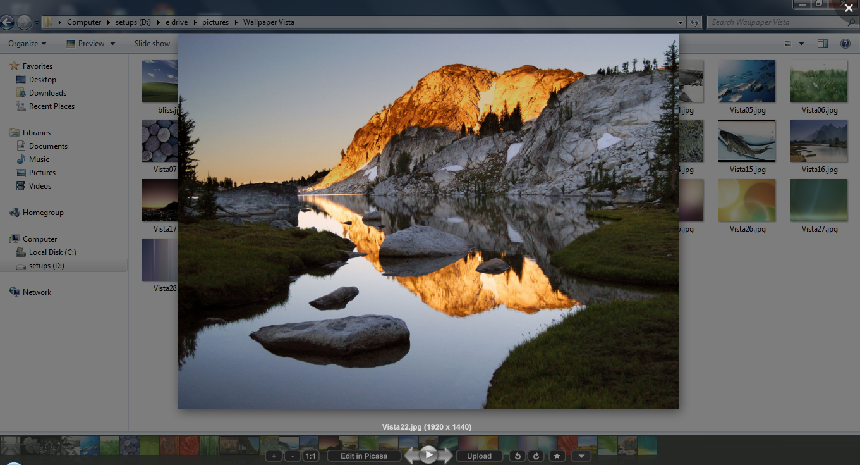

**Gmail:  
**Gmail is one of the best e-mail services available in the world with excellent features and facilities. Once Gmail came to the market, it completely destroyed Yahoo’s market which was one of the best e-mail service providers of that time. Gmail is very fast, easy to use and looks neat and clean. It operates extensively using AJAX (Asynchronous Javascript And XML) framework and this makes all the contents to get dynamically loaded. It provides lot of free space for the user to store their emails (approx. 7 GB) after which the user can pay and store their mails.   
Gmail services are also available for companies with their custom email ids like yourname@yourcompany.com and this feature is provided by Google APPS service. The amount of advertisements displayed in Gmail is less when compared to any other email service provider and this also makes the user stay in touch with Gmail.  
The users can also set themes if needed and modify the appearance of Gmail, chat with all their contacts using an embedded chat client, add apps like Google Calendar to their account and this makes Gmail very much user friendly.  
Moreover, Gmail has an excellent Spam filter which detects the mails which are not important to the user or mails which has more advertising content and adds it to the Spam area. It also checks for viruses like other mail clients before downloading any attachment thus providing security to the user.  
Recently, Gmail brought a feature by which it automatically marks important & unnecessary for the user by taking the help of the user’s history, activities and interests so that the user needs to read only the important mails rather than going through the entire inbox. The drawback of this feature is that even important mails can be marked as not important and vice versa. So, the user has to refer to the other mails also.  
  
 **YouTube:**C:\Users\VIGNESH - TECH AHOY\Desktop\VIGNESH FILES\MY BOOKMARKS\OTHER WEBPAGES\How to Build Links Fast  101 Tips & Strategies   SEO Book.com_files\youtube.gifThis video sharing service has been popular among most of the people in the world and is experiencing an exponential growth all over the days. It has a simple interface, vast storage facility, excellent filters, great community, fast streaming and great quality videos. All these add up to the credits of YouTube which has been entertaining its fans from a long period of time. Google bought YouTube for $1.65 billion in stock and YouTube has been a great success since then. The most viewed videos in YouTube included those of Justin Beiber “Baby”, few songs of Eminem and few songs of Lady Gaga.  
To encourage the users who upload, YouTube also gives Tags like “Most watched video of the month” and lots more tags which add to the credibility of the videos.  
  
When a video is uploaded into YouTube, it is automatically divided into frames so that people can have a look at the frames before deciding whether to watch the video or not. It provides usual features like sharing and embedding videos onto websites and the user can even decide the quality, size and resolution of the video to be displayed in their website while embedding.  
It operates with the help of Adobe Flash Player which is being used to play the videos for the user.  
YouTube also allows the user to categorize the videos on the basis of albums and even rate them so that it will be available for the user at ease.  
YouTube does not provide the feature of downloading the videos, but if needed, software like YouTube Downloader can be made use of. Even some websites like www.saveyoutube.com also provides the facility to download the videos as any format and quality from YouTube.

**Google Earth:**

  
Google Earth was a product which Google acquired from a start-up (Keyhole Inc.) in 2004.  
It has been put to use for rendering a 3 Dimensional view of the Earth where people can browse through various places, zoom in, zoom out, rotate and do similar operations to get a clear view of places. When zoomed in to the maximum possible level, even highways, buildings and other places are clearly visible and this marks Google’s success towards covering the entire globe.  
In this service, even tagging places is possible so that we can search for the respective place once tagged. This also acts as a very good information source for people to locate places they need.  
Zooming in is possible only till an extent after which the entire view becomes blurred.

**Android:**   
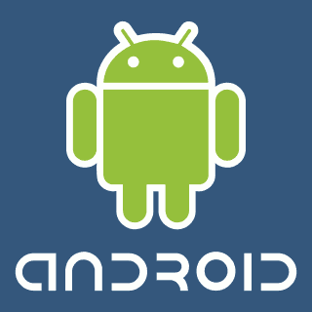  
Android is a Linux-based OS for mobile devices like smartphones and tablet computers. Its idea was conceptualized by ANDY RUBIN, RICK MINER and NICK SEARS in 23rd October 2003. Later it was purchased by Google. With the AOSP being led by Google the sole motto has become “To define an android compatible device that can run any app developed by third-party organization”. Google publishes most of the code under the Apache Licence Version 2.0.

Android 1.0 was launched on 23rd September 2008. Among the several features which were missing from the conventional phones are:- Android Market, web-browser, gmail synchronization with the gmail app, Google Maps, GTalk etc. However the most remarkable among them was the ability to drag down the notification bar. From then, it has never looked back and has launched several versions each better than its predecessor. The latest version is 4.0.4 (Ice Cream Sandwich) having features like facial recognition unlock, network data usage monitoring and control, unified social networking contacts, photography enhancements, offline email searching and information sharing using NFC.

Android apps run in a sandbox which is an isolated area of the OS that doesn’t have access to the rest of the system’s resources unless granted by the user. It is criticized for providing an inefficient and coarse grained permission system. Felt, Chin, Hamma observed that an install-time permission system is inefficient if developers routinely request more permission than they require. Over privileged apps expose users to unnecessary permission warning and increase the impact of a bug. As a result, several firms have released antivirus software.

Despite the above flaws Android has soared great heights. Canalys estimated in Q2 2009 that Android had a 2.8% share of worldwide smartphone shipments which dramatically became 52.5of smartphones.

Android apps don’t generate as much revenue for the developers as their Apple counterparts. They are also said to be of substandard quality. Due to these criticizes Google recently launched a new Android Design site aimed to help developers learn the principles. Moreover now developers plan to develop android platform apart from smartphones, for automobiles, PC’s, even household gadgets.

Now the internet giant (Google) is unifying the Android Market along with its books and movie services under the moniker Google Play. It’s beneficial as running a single service is better than running four separate fragments. The likes and dislikes of consumers can be easily watched and based on that information advertisements can be promoted. Many claim that Android will lose its dominance in the smartphone industry. But it’s a question only time can answer.

* Chaitanya Chauhan & Ritwij Goswami

**Google Play:**  
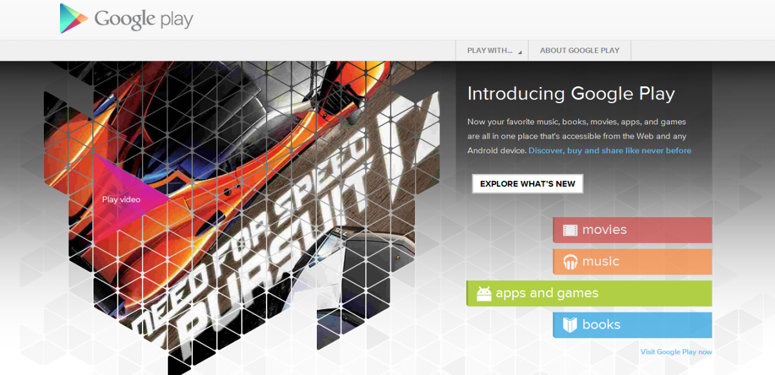  
  
  
  
  
  
**The What, Why and How of Gsoc:**

Gsoc or Google Summer of Code is an annual program in which students from all around the world are awarded stipends, provided they successfully complete a given open source project in the prescribed time. The program is open for students above the age of 18, enrolled in a university anywhere around the globe. The projects are not given out by Google but involve projects from different interested organizations from the open-source world like Mozilla and Apache. It is an opportunity for students to contribute to the open-source world under a big brand name which certainly enhances their job opportunities. Not only this, it also gives exposure to students, an opportunity to work with people around the globe from the same field, in the form of their mentors.

While Gsoc derives its name from the 1967's Summer of Love, the idea for Soc came from Google's founders Sergey Brin and Larry Page. Leslie Hawthorn was the program's manager until 2009 when Carol Smith took over the management.

The program consists of two kinds of work- students and mentors.

In order to participate as a student, you must be 18 years or older and a student. Google defines a student as " an individual enrolled in or accepted into an accredited institution including (but not necessarily limited to) colleges, universities, masters programs, PhD programs and undergraduate programs". You must provide all transcripts from their institution as a proof of you being a student, if requested by Google. Those who are not allowed to participate in the program includes Google employees, interns, contractors, family members, or residents and/or nationals of Iran, Syria, Cuba, Sudan, North Korea and Myanmar (Burma), with whom Google is prohibited by U.S. law from engaging in commerce.

Mentor organizations include individuals or companies approved by 'Google's Open Source Programs Office' who run an active free source software project. Again organizations from Iran, Syria, Cuba, Sudan, North Korea and Mynamar (Burma) are not alowed to participate due to legal issues. The criteria for mentors are decided by the mentoring organizations and not by Google.

The program started back in 2005 when Google received about 8740 project proposals for 200 available seats. The tremendous response forced Google to increase the number of seats to 419. Students who successfully completed their projects were awarded stipends of $4500 along with a Google T-shirt. The mentoring organizations were awarded stipends of $500.Since then the program has grown with 1115 students accepted in 2011. Even the number of participating organizations in 2011 counted to 175, of which 50 were new to the program. Google says the quality of applications has constantly risen which is satisfying as it fulfills the main motto behind the program. The program has brought together about 4500 students working in over 300 different open source projects. For this year Gsoc, 2012 was announced on February 4, this year and would end by August 24.

According to Google, the program mainly aims at creating a huge open source code to be used by everyone, inspire young minds to contribute to open source, help talented developers to get identified and give exposure to students. Google also clearly states that this program not a recruiting program and most of the work done during the program is not directly related to Google's line of business. They also state that most of the students who have participated in the program for the past several years are not employed in Google, though the program did make them more potential empployees.

THE GSOC PROCESS

Google publishes the evaluation questions beforehand, both for students and mentors.

Interested organizations first have to provide their administrators to represent them at the program. Their application should contain some basic description about them, the URL to their ideas page, their past involvement with the program, their plans etc for disappearing students etc. Google then selects the organizations and informs them of their acceptance.

As for students, they can submit their applications through the Google Summer of Code site. It was open for application by students from March 27 to April 6 this year. Google advises students to first interact with the oranization they want to work for as past experience says that the best applications are from students who interacted with the organizations. About a week and a half is provided for this interaction before student applications starts. In the application, student must mention their project proposals, the organizations they intend to work with etc. A student can submit as many as 20 applications but generally quality is preferred over quantity during the selection process. Ideally a student should submit 2-3 applications and not more than that.

The mentoring organizations then rank the student applications and select the best few from the list. Some other diligence activities may be conducted by the organizations which they feel is necessary.

Once you are selected, you will be notified and the coding period would start somewhere around May. You will also receive a starting stipend. Mid-term evaluations are carried out. If you satisfy the criteria demanded by the organization, you will be given half the stipend. If not, you are disqualified then and there. There is then a final evaluation at the end of the program. This determines if you get the remaining stipend amount, the t-shirt and the certificate or not.

THE PREPARATION TRICK...

For GSoC, getting selected is considered tougher than completing it once you are in. So what is it which would make the mentoring organizations look at you differently? Being the topper of your college won’t be of any use. College projects do not help either as they are not related to the organization’s field of work. The only way you can prove that you can complete the project is by contributing code before the program with just one motive: to do something good for the world. Join mailing lists of previous year's accepted organisations; study their code. Be active in the mailing list and the IRC. The more active you are in contributing to the open source world, the more are your chances of getting selected. Never get disheartened on your proposal getting rejected. Try to find out what went wrong; and make it better next time. So go out there and code your heart out. You will not only be doing service to others by providing code for free but at the same time, will also earn some money and reputation for yourself. It’s an opportunity not only to prove to the world but also to you.

-Sumedh Shekhar